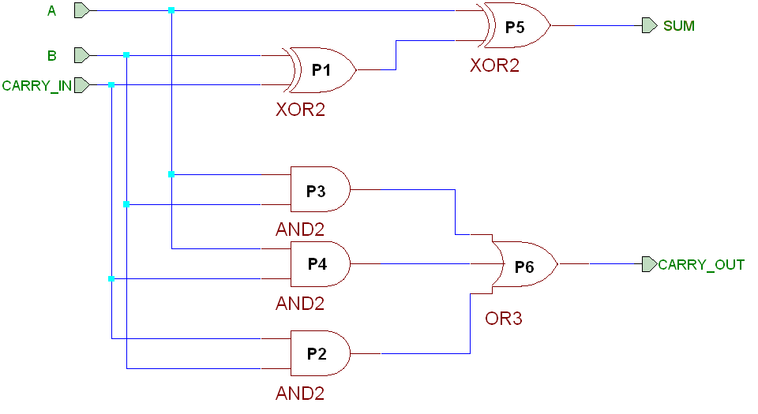
Figura 8.2 Sumator complet de numere pe un bit

entity SUMATOR_COMPLET is
port (A, B, CARRY_IN: in BIT;
SUM, CARRY_OUT: out BIT);
end SUMATOR_COMPLET ;
architecture ARH1 of SUMATOR_COMPLET is
signal S1, S2, S3, S4: BIT;
begin
P1: process(B, CARRY_IN)
begin
S1 <= B xor CARRY_IN;
end process P1;
P2: process(B, CARRY_IN)
begin
S2 <= B and CARRY_IN;
end process P2;
P3: process(A, B)
begin
S3 <= A and B;
end process P3;
P4: process(A, CARRY_IN)
begin
S4 <= A and CARRY_IN;
end process P4;
P5: process(A, S1)
begin
SUM <= A xor S1;
end process P5;
P6: process(S2, S3, S4)
begin
CARRY_OUT <= S2 or S3 or S4;
end process P6;
end architecture ARH1;

